CS 340 README Project Two

About the Project/Project Title
This project is an interactive animal shelter dashboard created for Grazioso Salvare. The dashboard connects Python to the aac MongoDB database and displays records from the animals collection. Users can filter animal records based on rescue needs, review the results in a data table, view a chart of the breeds in the current results, and see a map marker for a selected animal.
The dashboard includes Water Rescue, Mountain or Wilderness Rescue, and Disaster or Individual Tracking filters, along with a Reset option. The table supports sorting, filtering, pagination, and selecting one animal at a time. The breed chart updates based on the current table results, and the map displays the selected animal's location with a breed tooltip and name popup.

Motivation
The goal of this project was to make animal shelter records easier for Grazioso Salvare to review when looking for animals that may fit different rescue roles. Rather than searching through records manually, users can select a rescue category and quickly see matching animals. The project also provided practice connecting a database to Python and using Dash callbacks to make a dashboard interactive.

Getting Started
The following steps can be used to set up the database and run the dashboard.
1. Install MongoDB and make sure the MongoDB server is running.
2. Import aac_shelter_outcomes.csv into a database named aac and a collection named animals. Include the CSV header as the field names.
3. Create a MongoDB user with the database permissions required for the project. Read access is needed to display dashboard records; write access is only needed if performing separate CRUD tests.
4. Open CRUD_Python_Module.py and check the host, port, database name (aac), collection name (animals), username, and password.
5. Make sure the dashboard code imports AnimalShelter from CRUD_Python_Module.py and that Grazioso Salvare Logo.png is in the file path used by the code.
6. Install the Python packages in the environment used to run the notebook. One option is: python -m pip install jupyter-dash dash dash-leaflet plotly pandas numpy matplotlib pymongo
7. Open JupyterLab or Jupyter Notebook and run the dashboard cells in order.
8. Run the final cell to launch the dashboard. If the default port is already in use, configure an available port for the installed Dash/JupyterDash version.
9. Test each rescue filter and then choose Reset to confirm that all animal records return.
10. Test table sorting, filtering, pagination, and single-row selection. Confirm that the breed chart and map update when the table data or selected animal changes.

Installation

The main tools used for this project were Python, MongoDB, PyMongo, JupyterLab/Jupyter Notebook, Dash/JupyterDash, Pandas, Plotly Express, and dash-leaflet. Python was used for the application logic. MongoDB stores the shelter records as documents, which makes it convenient to work with records that contain named fields. MongoDB also supports query operators such as $in, $gte, and $lte, which are used to filter records by breed and age.
PyMongo provides the connection between Python and MongoDB. The AnimalShelter class in the CRUD module uses it to read records from the animals collection. The read results can then be converted into a Pandas DataFrame for use by the dashboard.
Dash provides the structure for the web application. The layout defines the visible components, including radio buttons, the table, chart, and map. Dash callbacks act as the controller by responding to selections and updating the displayed data. JupyterDash allows the application to run in a notebook environment. Plotly Express creates the breed pie chart, while dash-leaflet displays the map and animal marker.

Usage
When the dashboard starts, it creates an AnimalShelter object using the configured MongoDB login information. The initial read({}) call retrieves all animal records and converts them into a Pandas DataFrame. The _id field is removed before the data is passed to the table because MongoDB ObjectId values are not directly suitable for display in the Dash data table.
When a rescue filter is selected, the update_dashboard callback sends a matching query through the CRUD module's read() method. Water Rescue filters for Labrador Retriever Mix, Chesapeake Bay Retriever, and Newfoundland dogs that are intact females between 26 and 156 weeks old. Mountain or Wilderness Rescue uses its configured breed list and selects intact males between 26 and 156 weeks old. Disaster or Individual Tracking uses its configured breed list and selects intact males between 20 and 300 weeks old. Reset sends an empty query to display all records.
The chart callback counts the breeds in the current table results and displays them in a pie chart. The map callback uses the selected row's latitude and longitude to place a marker. The current code accesses the coordinate fields by column position, so the dataset's column order must remain consistent with the code. Using field names instead of numeric positions would make this part easier to maintain.

Tests
The dashboard should be tested by launching it from JupyterLab or Jupyter Notebook and checking each interactive component. Select each rescue filter and verify that the table changes. Choose Reset to return to all records. Sort and filter the table, move between pages, and select an animal. Confirm that the breed chart reflects the displayed results and that the map marker and popup correspond to the selected animal.
One challenge was handling MongoDB results in a format that the dashboard could display. MongoDB returns a cursor from find(), so the CRUD module converts results to a list. The dashboard then converts the records to a DataFrame and drops the _id field. Another challenge was keeping the table, chart, and map in sync. Dash callbacks address this by using the current table data and selected row as inputs. The chart callback also checks for empty results or a missing breed field so it can display a message instead of trying to make a chart from invalid input.
The notebook environment can also require proxy configuration, and the default application port may already be in use. The code calls JupyterDash.infer_jupyter_proxy_config(); if the default port is unavailable, use another port supported by the installed version.
For security, do not share or commit real database passwords in the source code. Replace embedded credentials with environment variables or secure local configuration before sharing or deploying the project.

Screenshots
Initial Screen
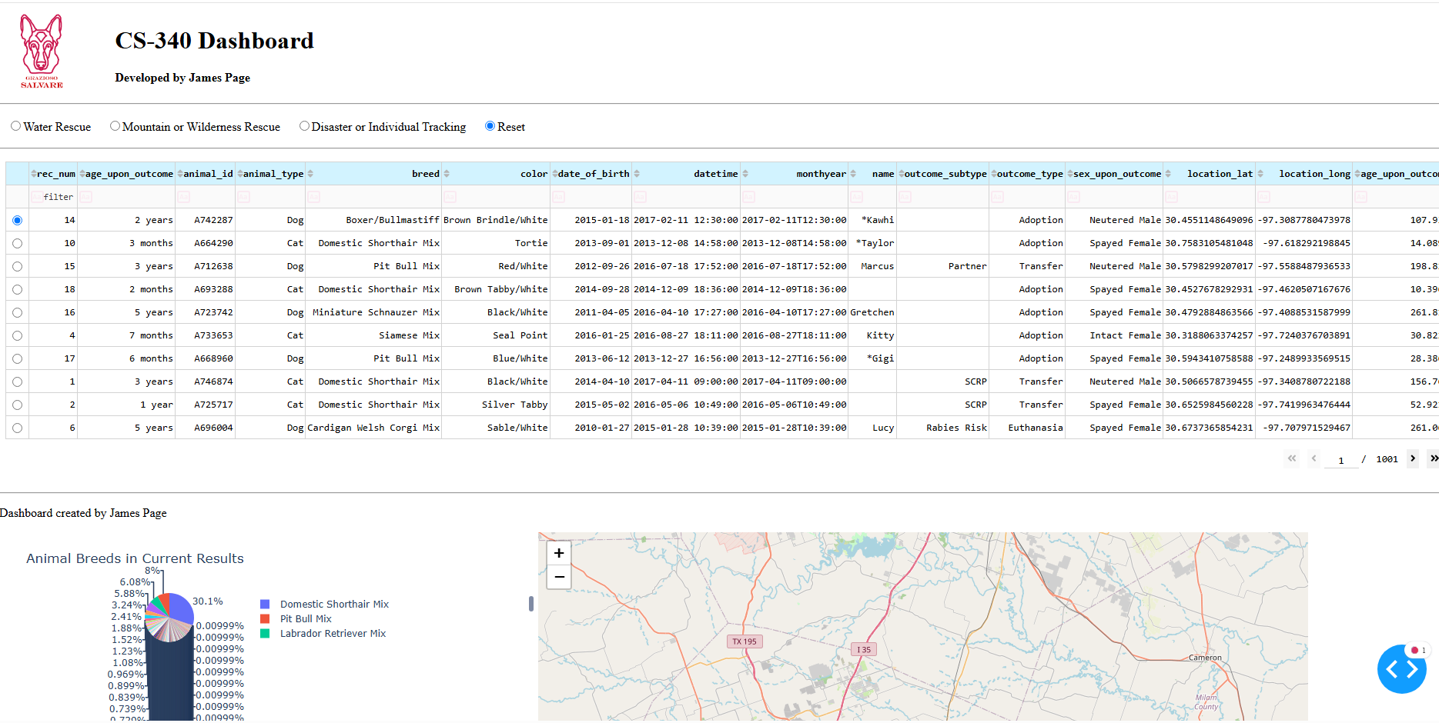
Water Rescue
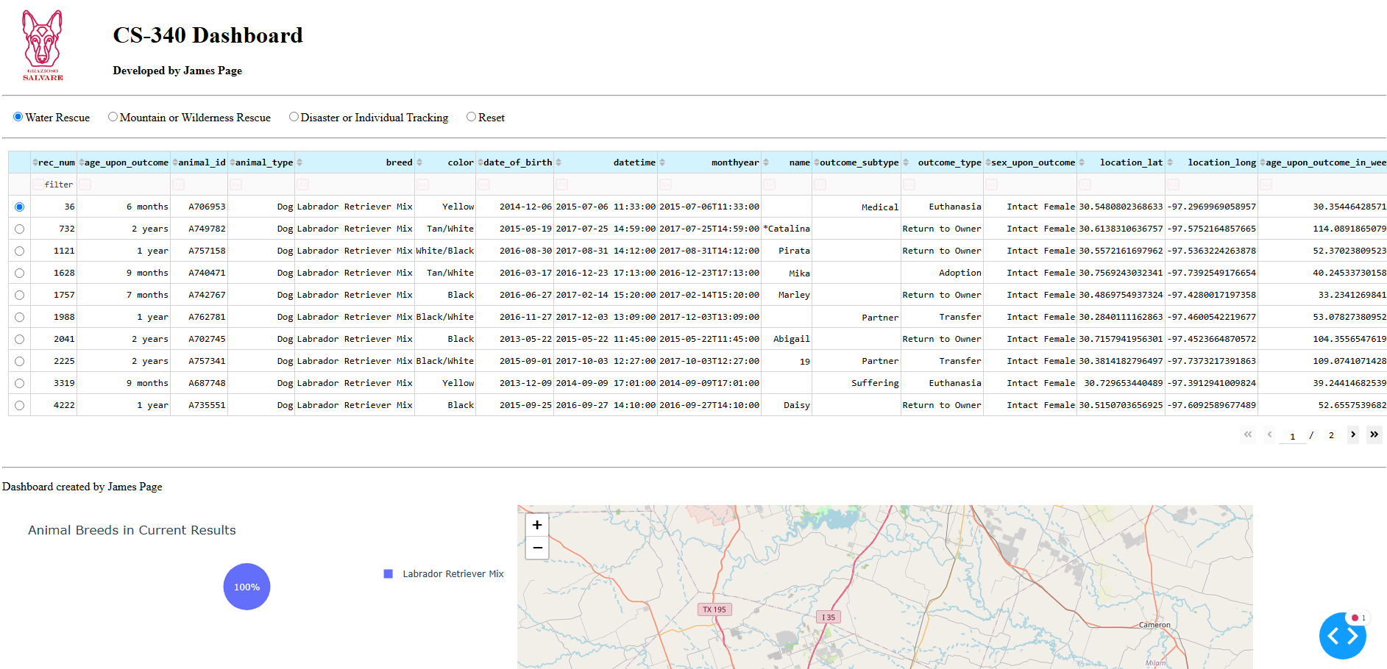
Mountain or Wilderness

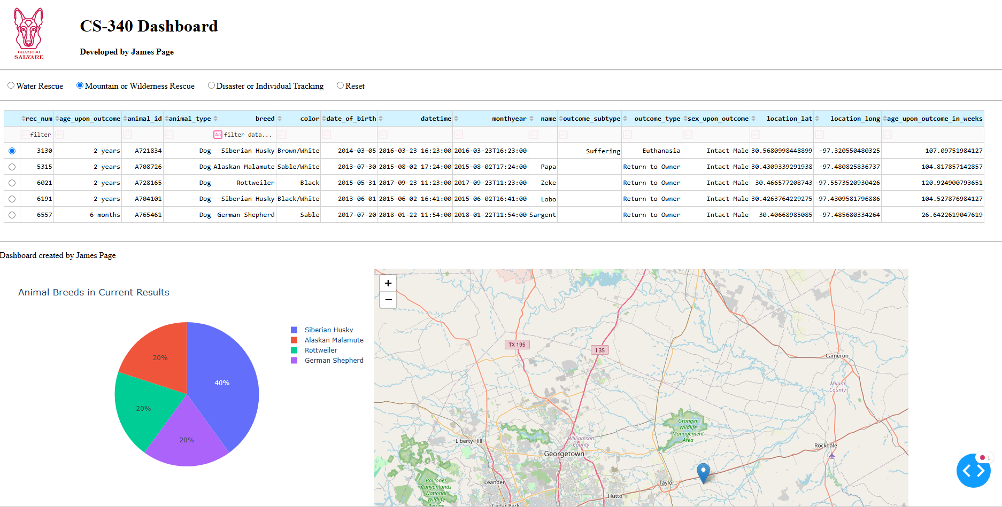
Disaster/Individual Tracking

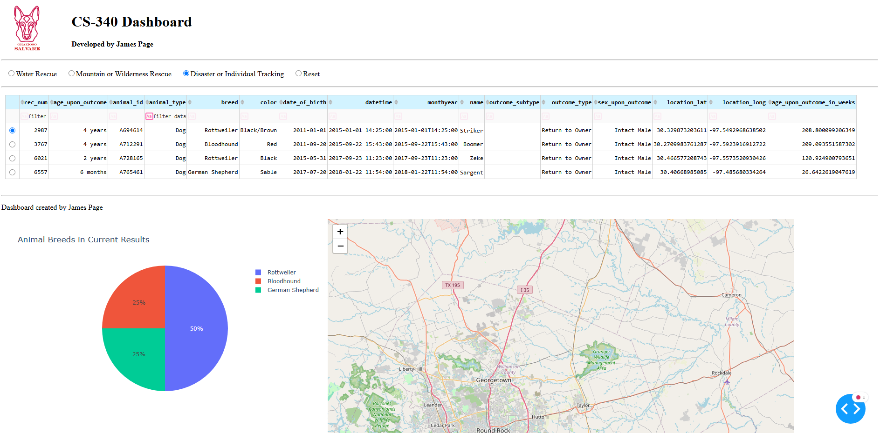
Reset
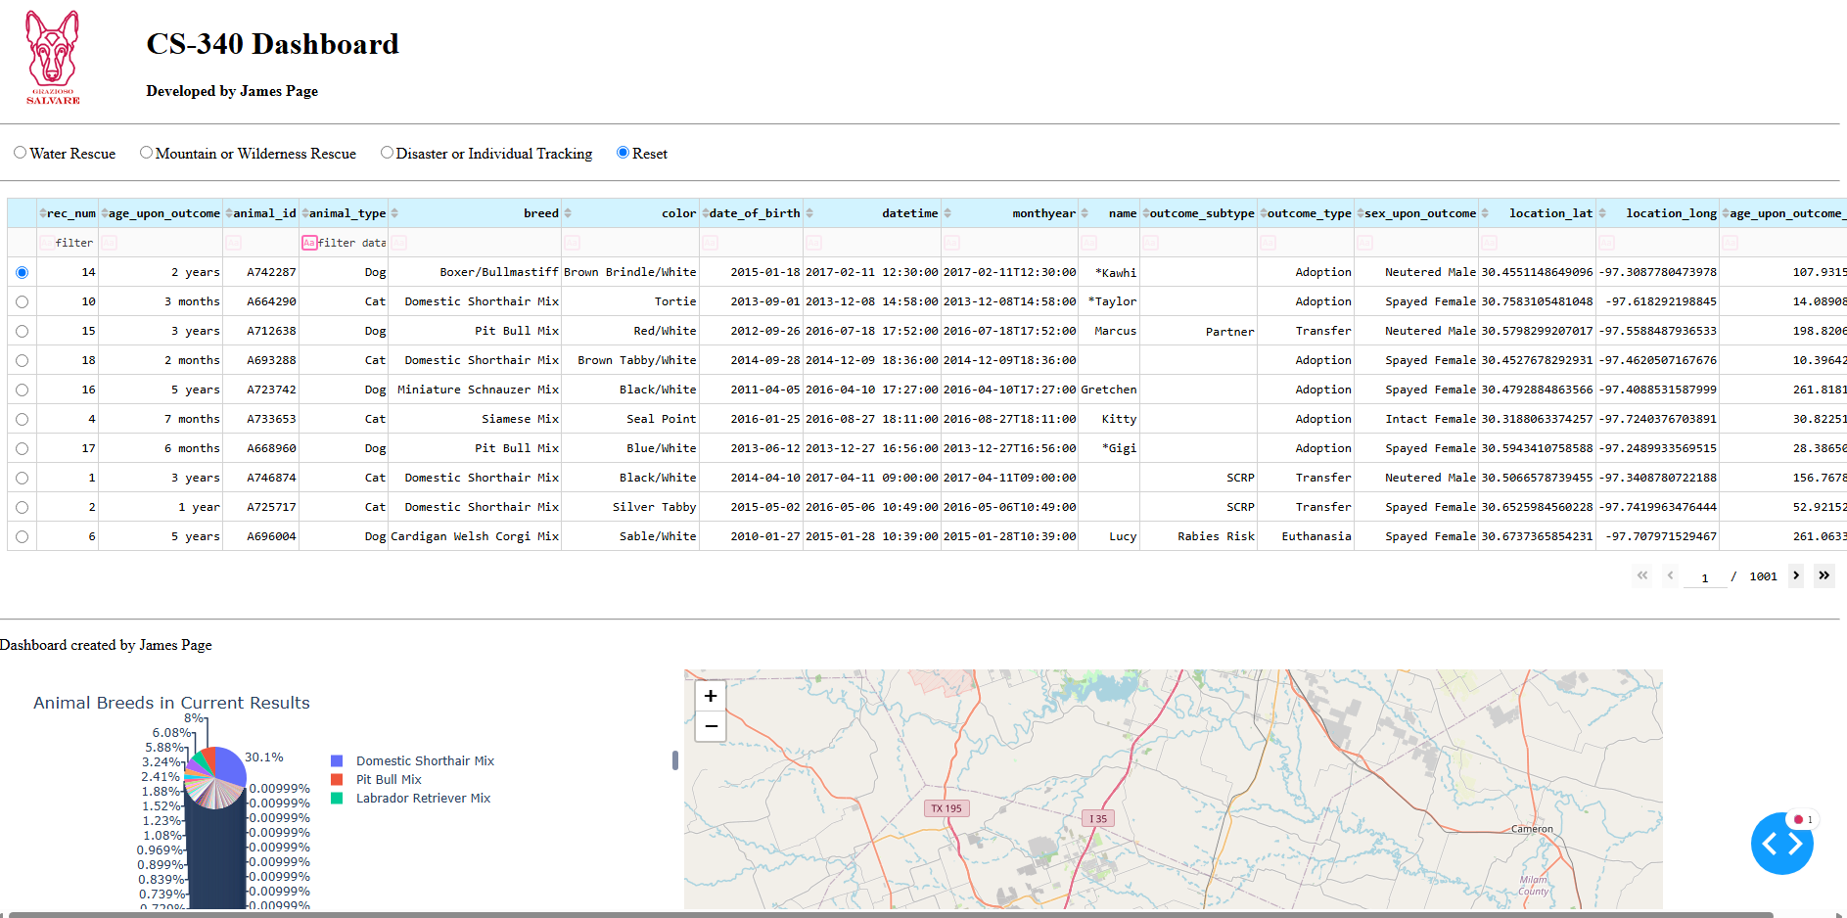

Contact
Your name: James Page

